Title: DEVELOPMENT OF SMART CITY INFORMATION PORTAL USING TYPESCRIPT AND ANGULAR
Aim: To upgrade the existing Smart City Information Portal into an Angular-based single-page application using TypeScript, components, templates, data binding, routing and services, and to retrieve Public Transport information dynamically from the existing Node.js and Express server using Angular HTTP Client.
Upgrade the existing Smart City Information Portal so that:
1 | The existing portal is reorganized as an Angular application.
2 | Home, About City, City Services, Emergency Information and Public Transport are maintained as separate functional sections.
3 | Citizens can navigate between these sections within the application.
4 | Application data is represented using suitable TypeScript structures.
5 | Data and user-interface information are displayed dynamically without manual DOM manipulation.
6 | Server communication is separated from presentation logic.
7 | Existing Public Transport information is obtained from the Node.js and Express server.
8 | Transport information received in JSON format is displayed in the Public Transport section.
9 | A suitable message is displayed if transport information cannot be obtained.
10 | Existing Smart City HTML content and CSS are retained wherever appropriate.

Observation:
STEP 1 — Verify the Development Environment
Angular development requires Node.js and npm.

1.1 Check Node.js
node -v
1.2 Check npm
npm -v

STEP 2 — Install Angular CLI
Run:
npm install -g @angular/cli
Verify installation:
ng version

Command | Purpose
node | Runs JavaScript outside the browser
npm | Installs packages
ng | Angular CLI
TypeScript | Language used for Angular application logic
Angular | Framework used to construct the frontend

STEP 3 — Keep Week 11 Backend and Week 12 Frontend Separately
Create the following arrangement:
SmartCityProject/
│
├── smart-city-server/
│ └── Week 11 files
└── smart-city-angular/
└── Week 12 Angular application
Why?
Angular
↓
FRONTEND

Node.js + Express
↓
BACKEND
Week 12 is upgrading the frontend, while the Week 11 backend remains useful.

STEP 4 — Create the Angular Application
Move to:
SmartCityProject/
Run:
ng new smart-city-angular --routing --style=css
If Angular CLI asks additional setup questions, use the standard/default beginner configuration selected for your laboratory installation.
Move inside the project:
cd smart-city-angular
Open it in VS Code:
code .

STEP 5 — Test the Angular Application Before Modification
Run:
ng serve
Open the URL displayed in the terminal, normally:
http://localhost:4200

STEP 6 — Understand the Angular Files
Open: src/
The important responsibilities are:
File | Responsibility
index.html | Main browser document
styles.css | Global styles
app/ | Angular application
Root component .ts | Application logic
Root component .html | Main template
app.routes.ts | Application navigation
Application configuration | Angular providers/configuration
package.json | Dependencies
tsconfig.json | TypeScript configuration

STEP 7 — TypeScript Is Required
The existing Week 11 JavaScript might represent transport data as:
let fare = 20;
let available = true;
let transportName = "City Bus";
In TypeScript:
let fare: number = 20;
let available: boolean = true;
let transportName: string = "City Bus";

Data | Type
"City Bus" | string
20 | number
true | boolean

STEP 8 — Generate Smart City Components
Our existing portal contains different functional areas.
Instead of maintaining each as a complete independent webpage, create Angular components.
Stop ng serve if required using:
Ctrl + C
Generate the components:
ng generate component home
ng generate component about
ng generate component services
ng generate component emergency
ng generate component transport
Short form:
ng g c home
may also be used.
Checkpoint 2
Look inside:
src/app/
Component files/folders should now be generated.
ANGULAR
Component
├── Template
├── TypeScript
└── CSS

STEP 9 — Move Existing Home Content to Home Component
Open the generated Home component HTML template.
Do not copy:
<!DOCTYPE html>
<html>
<head>
<body>
from the previous webpage.
Copy only the existing Home page content.
For example:
<section>
<h2>Welcome to Smart City</h2>
<p>
Welcome to the Smart City Information Portal.
Access important municipal information and
citizen services from one place.
</p>
</section>

STEP 10 — Migrate the Remaining Existing HTML Content
Perform the same operation for the other existing Smart City sections.
Existing portal content | Angular component
Home | Home
About City | About
City Services | Services
Emergency Information | Emergency
Public Transport | Transport

STEP 11 — Configure the Root Application
The common website structure should remain in the root template.
Open the generated root component HTML template and replace the default demonstration content with:
<header>
<h1>Smart City Information Portal</h1>
<p>Municipal Corporation</p>

</header>
<nav>
<a routerLink="/home"> Home </a>
<a routerLink="/about">About City </a>
<a routerLink="/services">City Services </a>
<a routerLink="/emergency">Emergency </a>
<a routerLink="/transport">Public Transport </a>
</nav>
<main>
<router-outlet></router-outlet>
</main>
<footer> <p> &copy; Smart City Municipal Corporation </p></footer>

STEP 12 — Enable Router Features in the Root Component
Because the project uses standalone Angular components, the root component must have access to routing directives used by its template.
Open the generated root component TypeScript file.
Ensure the required router features are imported:
import { Component } from '@angular/core';
import {
RouterLink,
RouterOutlet
} from '@angular/router';
Then include them in the component imports:
@Component({
selector: 'app-root',
imports: [
RouterLink,
RouterOutlet
],
templateUrl: './app.html',
styleUrl: './app.css'
})
Use the actual root template/style filenames generated by the installed Angular CLI.

STEP 13 — Configure Routes
Open:
src/app/app.routes.ts
Import the generated components.
For example:
import { Routes } from '@angular/router';
import { HomeComponent }
from './home/home.component';
import { AboutComponent }
from './about/about.component';
import { ServicesComponent }
from './services/services.component';
import { EmergencyComponent }
from './emergency/emergency.component';
import { TransportComponent }
from './transport/transport.component';

Important: Angular CLI versions can generate different component filenames/class names. Use the names generated on the laboratory system.
Define the routes:
export const routes: Routes = [
{
path: '',
redirectTo: 'home',
pathMatch: 'full' },
{
path: 'home',
component: HomeComponent
},
{
path: 'about',
component: AboutComponent
},
{
path: 'services',
component: ServicesComponent
},
{
path: 'emergency',
component: EmergencyComponent
},
{
path: 'transport',
component: TransportComponent
}
];
Checkpoint 3
Run:
ng serve
Test:
/home
/about
/services
/emergency
/transport
Click the navigation links.
Expected
The content inside:
<router-outlet>
changes without loading separate complete HTML documents.

STEP 14 — Migrate the Existing CSS
Open the old:
style.css
from the Smart City portal.
Copy the global styles that are still applicable to:
src/styles.css
For example, existing rules for:
body {
/* existing Week 5 styles */
}
header {
/* existing styles */
}
nav {
/* existing styles */
}
nav a {
/* existing styles */
}
footer {
/* existing styles */
}
should be retained.
Component-specific styling can be placed in the CSS file belonging to that component.
STEP 15 — Create a TypeScript Model for Transport
Now implement the Week 12 TypeScript requirement using our existing Week 11 transport data.
Create:
src/app/models/
Inside it create:
transport.ts
Enter:
export interface Transport {
name: string;
route: string;
start: string;
destination: string;
fare: number;
available: boolean;
}
STEP 16 — Verify the Existing Week 11 Server
Now switch to the Week 11 backend project.
The server should retain the transport array:
const transports = [

{
name: "City Bus",
route: "Route 101",
start: "Central Bus Station",
destination: "Railway Station",
fare: 20,
available: true
},

{
name: "Metro",
route: "Blue Line",
start: "City Centre",
destination: "Airport",
fare: 40,
available: true
},

{
name: "Electric Bus",
route: "E-20",
start: "Municipal Office",
destination: "University",
fare: 25,
available: false
},

{
name: "City Shuttle",
route: "S-10",
start: "Railway Station",
destination: "Bus Terminal",
fare: 15,
available: true
}

];
and:
app.get(
"/api/transport",
function (req, res) {
res.json(transports);
}
);
Run:
node app.js
Open:
http://localhost:3000/api/transport

STEP 17 — Allow Angular to Communicate with the Server
Angular development server and Express server run at different addresses.
Angular
http://localhost:4200
Express
http://localhost:3000
For this beginner lab configuration, enable CORS on Express.
In the server project, stop the server and run:
npm install cors
Open:
app.js
Add:
const cors = require("cors");
After creating the Express application:
const app = express();
app.use(cors());
Restart:
node app.js

STEP 18 — Configure Angular HTTP Client
Return to:
smart-city-angular
Open the generated Angular application configuration file, commonly:
src/app/app.config.ts
Import:
import {
provideHttpClient
} from '@angular/common/http';
Add it to the existing providers.
For example:
export const appConfig: ApplicationConfig = {
providers: [
provideRouter(routes),
provideHttpClient()
]
};

STEP 19 — Generate the Transport Service
Run:
ng generate service services/transport
Angular creates the service file.

STEP 20 — Implement transport.service.ts
Open the generated transport service.
Enter:
import {
Injectable
} from '@angular/core';
import {
HttpClient
} from '@angular/common/http';
import {
Observable
} from 'rxjs';
import {
Transport
} from '../models/transport';
@Injectable({
providedIn: 'root'
})
export class TransportService {
private apiUrl: string =
'http://localhost:3000/api/transport';
constructor(
private http: HttpClient
) { }
getTransports():
Observable<Transport[]> {
return this.http.get<Transport[]>(
this.apiUrl
);
}
}

STEP 21 — Configure the Transport Component
Open the generated Transport component TypeScript file.
The exact decorator metadata depends on the CLI-generated project, but its logic should contain:
import {
Component
} from '@angular/core';
import {
CommonModule
} from '@angular/common';
import {
Transport
} from '../models/transport';
import {
TransportService
} from '../services/transport.service';
@Component({
selector: 'app-transport',
imports: [
CommonModule
],
templateUrl:
'./transport.component.html',
styleUrl:
'./transport.component.css'
})

export class TransportComponent {
transports: Transport[] = [];
message: string = "";
constructor(
private transportService:
TransportService
) { }

loadTransport(): void {
this.message =
"Loading transport information...";
this.transportService
.getTransports()
.subscribe({
next: (data) => {
this.transports =
data;
this.message =
"Transport information loaded successfully.";
},
error: () => {
this.message =
"Unable to obtain transport information.";
}
});
}
}
STEP 22 — Create the Transport Template
Open the Transport component HTML template.
Enter:
<section>
<h2>
Public Transport Information
</h2>
<p>
View current public transport
information provided by the
Municipal Corporation.
</p>
<button
type="button"
(click)="loadTransport()">
Load Transport Information
</button>
<p> {{ message }} </p>
<article*ngFor="let transport of transports">
<h3> {{ transport.name }}</h3>
<p><strong>Route:</strong> {{ transport.route }}</p>
<p> <strong>Starting Point:</strong>{{ transport.start }} </p>
<p> <strong>Destination:</strong> {{ transport.destination }}</p>
<p> <strong>Fare:</strong> ₹{{ transport.fare }} </p>
<p><strong>Availability:</strong>
{{
transport.available
? 'Available'
: 'Not Available'
}}
</p>
</article>
</section>

STEP 23 — Identify the Angular Concepts Used
Code | Concept
{{ message }} | Interpolation
(click)="loadTransport()" | Event binding
*ngFor | Directive for repeated display
Transport[] | TypeScript typed array
Transport | Interface
TransportService | Angular service
Constructor parameter | Dependency injection
HttpClient | Server communication
routerLink | Navigation
router-outlet | Routed component display

STEP 26 — Configure app.js
const express = require("express");
const cors = require("cors");
const path = require("path");
const app = express();
// --------------------------------------------------
// Allow Angular Frontend
// --------------------------------------------------
app.use(cors({origin: "http://localhost:4200"}));
// --------------------------------------------------
// Serve Existing Smart City Files
// --------------------------------------------------
app.use(express.static("public"));
// --------------------------------------------------
// Home Route
// --------------------------------------------------
app.get("/", function (req, res) {
res.sendFile(
path.join(
__dirname,
"public",
"index.html"
)
);
});
// --------------------------------------------------
// Public Transport Data
// --------------------------------------------------
const transports = [
{
name: "City Bus",
route: "Route 101",
start: "Central Bus Station",
destination: "Railway Station",
fare: 20,
available: true
},
{
name: "Metro",
route: "Blue Line",
start: "City Centre",
destination: "Airport",
fare: 40,
available: true
},
{
name: "Electric Bus",
route: "E-20",
start: "Municipal Office",
destination: "University",
fare: 25,
available: false
},
{
name: "City Shuttle",
route: "S-10",
start: "Railway Station",
destination: "Bus Terminal",
fare: 15,
available: true
}
];
// --------------------------------------------------
// Transport API
// --------------------------------------------------
app.get("/api/transport", function (req, res) { res.json(transports);});
// --------------------------------------------------
// Start Express Backend
// --------------------------------------------------
app.listen(3000, function () {
console.log("Smart City Server running at http://localhost:3000");
console.log("Angular Frontend expected at http://localhost:4200"); });

STEP 25 — Run Both Applications
Go to: smart-city-server/
Run: node app.js
Server: http://localhost:3000

Terminal 2 — Frontend
Go to: smart-city-angular/
Run: ng serve
Frontend: http://localhost:4200

Application | Folder | Command | Address
Backend Server | smart-city-server | node app.js | http://localhost:3000
Angular Frontend | smart-city-angular | ng serve | http://localhost:4200

STEP 26 — Test Navigation
Open: http://localhost:4200
Click:
Home
About City
City Services
Emergency
Public Transport

STEP 27 — Final File Structure
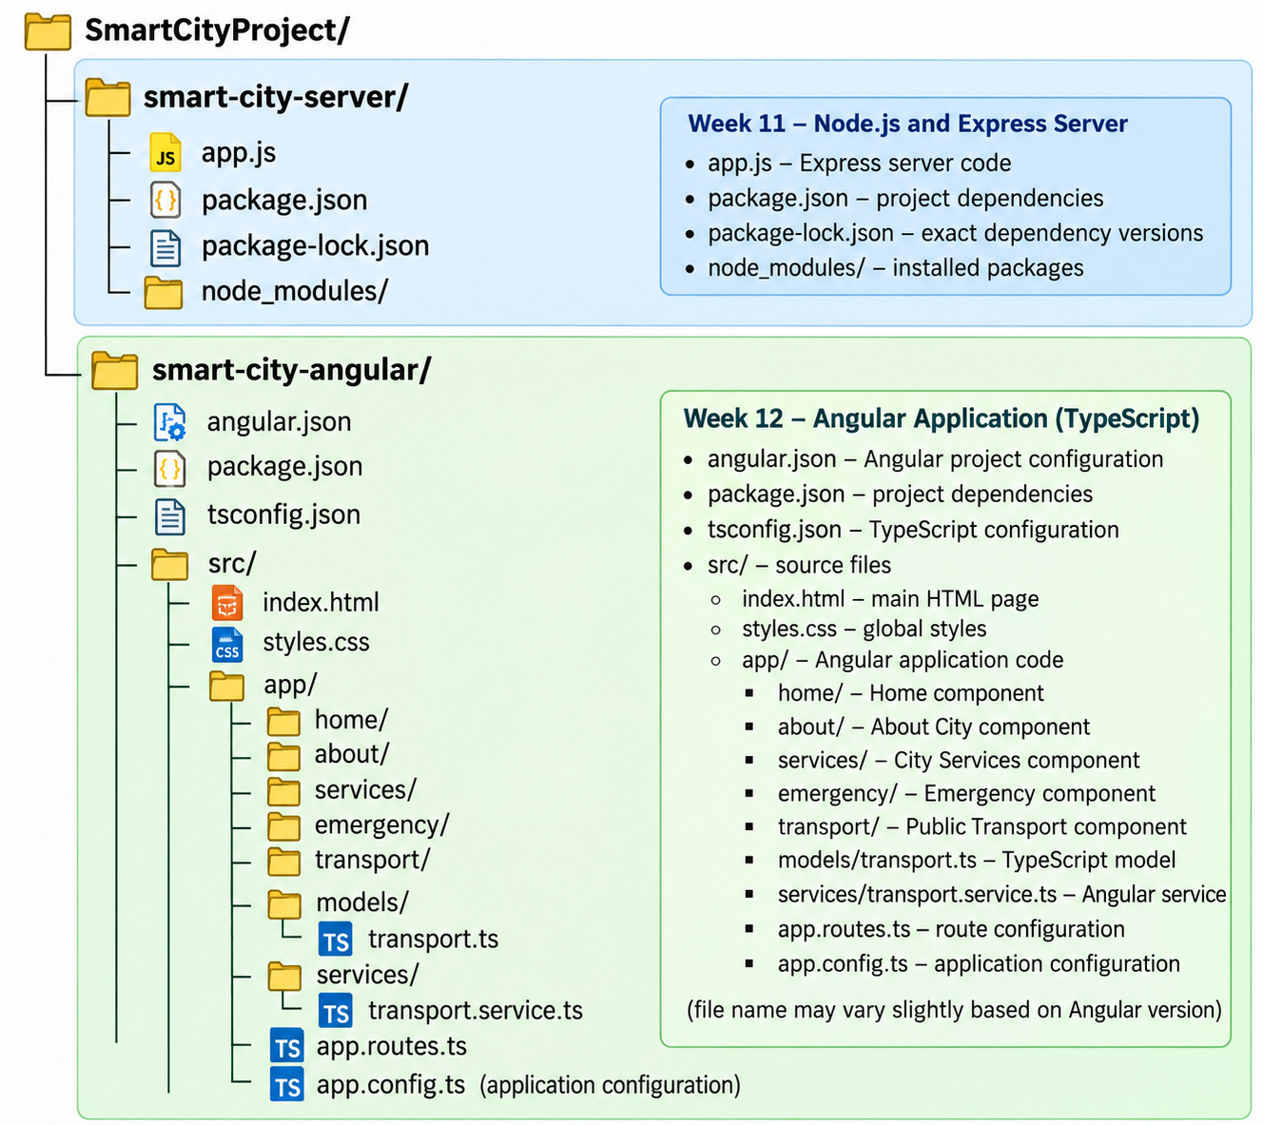

Result:
The existing Smart City Information Portal was successfully upgraded into an Angular-based single-page application using TypeScript, components, templates, data binding, routing, services, dependency injection and HTTP Client. The Angular frontend was integrated with the existing Node.js and Express backend to retrieve and display Public Transport information dynamically in JSON format.

